=> ALV_LOGO

REPORT z392_alv_logo NO STANDARD PAGE HEADING LINE-COUNT 20(3).  
INCLUDE Z392_ALV_LIST_top.  
  
SELECT-OPTIONS S_vbeln FOR LV_vbeln OBLIGATORY.  
  
INITIALIZATION.  
  CLEAR : it_tab, wa_fieldcat, lt_fieldcat.  
  S_vbeln-low = '1'.  
  S_vbeln-high = '100'.  
  APPEND s_vbeln.  
  
AT SELECTION-SCREEN ON S_vbeln.  
  SELECT SINGLE vbeln  
    INTO LV_vbeln  
    FROM vbap  
    WHERE vbeln IN S_vbeln.  
  
  
START-OF-SELECTION.  
  PERFORM get_alv_fcat.  
  
  PERFORM get_mat_data.  
  
END-OF-SELECTION.  
 PERFORM display_alvout.  
  
*&---------------------------------------------------------------------*  
*& Form GET_ALV_FCAT  
*&---------------------------------------------------------------------*  
*& text  
*&---------------------------------------------------------------------*  
*& -->  p1        text  
*& <--  p2        text  
*&---------------------------------------------------------------------*  
FORM get_alv_fcat .  
  
  wa_fieldcat-col_pos = '1'.  
  wa_fieldcat-seltext_l = text-001.  
  wa_fieldcat-fieldname = cs_vbeln.  
  wa_fieldcat-tabname = cs_tab.  
  
  APPEND wa_fieldcat TO lt_fieldcat.  
  CLEAR wa_fieldcat.  
  
  wa_fieldcat-col_pos = '2'.  
  wa_fieldcat-seltext_l = text-002.  
  wa_fieldcat-fieldname = cs_matnr.  
  wa_fieldcat-tabname = cs_tab.  
  
  APPEND wa_fieldcat TO lt_fieldcat.  
  CLEAR wa_fieldcat.  
  
  wa_fieldcat-col_pos = '3'.  
  wa_fieldcat-seltext_l = text-003.  
  wa_fieldcat-fieldname = 'posnr'.  
  wa_fieldcat-tabname = 'lt_tab'.  
  
  APPEND wa_fieldcat TO lt_fieldcat.  
  CLEAR wa_fieldcat.  
  
  wa_fieldcat-col_pos = '4'.  
  wa_fieldcat-seltext_l = text-004.  
  wa_fieldcat-fieldname = 'matkl'.  
  wa_fieldcat-tabname = 'lt_tab'.  
  
  APPEND wa_fieldcat TO lt_fieldcat.  
  CLEAR wa_fieldcat.  
  
ENDFORM.  
*&---------------------------------------------------------------------*  
*& Form get_mat_data  
*&---------------------------------------------------------------------*  
*& text  
*&---------------------------------------------------------------------*  
*& -->  p1        text  
*& <--  p2        text  
*&---------------------------------------------------------------------*  
FORM get_mat_data .  
  SELECT   vbeln MATNR posnr matkl  
    INTO TABLE it_tab  
    FROM vbap  
    WHERE vbeln IN s_vbeln.  
  
ENDFORM.  
*&---------------------------------------------------------------------*  
*& Form display_alvout  
*&---------------------------------------------------------------------*  
*& text  
*&---------------------------------------------------------------------*  
*& -->  p1        text  
*& <--  p2        text  
*&---------------------------------------------------------------------*  
FORM display_alvout .  
  
  data lv_title type lvc_title value ' MAT MASTER INFO'.  
  
  ty_layout-no_colhead = 'X'.  
  ty_layout-no_vline = 'X' .  
  ty_layout-no_hline = 'X'.  
  
  if sy-subrc eq 0.  
  
  
  
CALL FUNCTION 'REUSE_ALV_GRID_DISPLAY'  
  EXPORTING  
    I_CALLBACK_PROGRAM                =  SY-REPID  
*     I_CALLBACK_PF_STATUS_SET          = ' '  
*     I_CALLBACK_USER_COMMAND           = ' '  
    I_CALLBACK_TOP_OF_PAGE            =  'UST_LOGO'  
    I_GRID_TITLE                      =  lv_title  
*     I_GRID_SETTINGS                   =  
*     IS_LAYOUT                         =  
     IT_FIELDCAT                       = LT_FIELDCAT  
  
    TABLES  
      t_outtab                          = IT_TAB  
 EXCEPTIONS  
    PROGRAM_ERROR                     = 1  
    OTHERS                            = 2  
            .  
  IF sy-subrc <> 0.  
* Implement suitable error handling here  
  ENDIF.  
ENDIF.  
  
ENDFORM.  
  
  
  
FORM UST_LOGO.  
  DATA : lt_header TYPE slis_t_listheader,  
         wa_header TYPE slis_listheader.  
  
  wa_header-typ = 's'.  
    wa_header-info = 'UST GLOBAL'.  
  wa_header-key = 'HYDERABAD'.  
  append wa_header to lt_header.  
  
  wa_header-typ = 'S'.  
  wa_header-info = sy-datum.  
  wa_header-key = sy-uzeit.  
  append wa_header to lt_header.  
  
  
CALL FUNCTION 'REUSE_ALV_COMMENTARY_WRITE'  
  EXPORTING  
    it_list_commentary       = LT_HEADER  
  I_LOGO                   = 'Z292_LOGO'  
*   I_END_OF_LIST_GRID       =  
*   I_ALV_FORM               =  
          .  
  
ENDFORM.

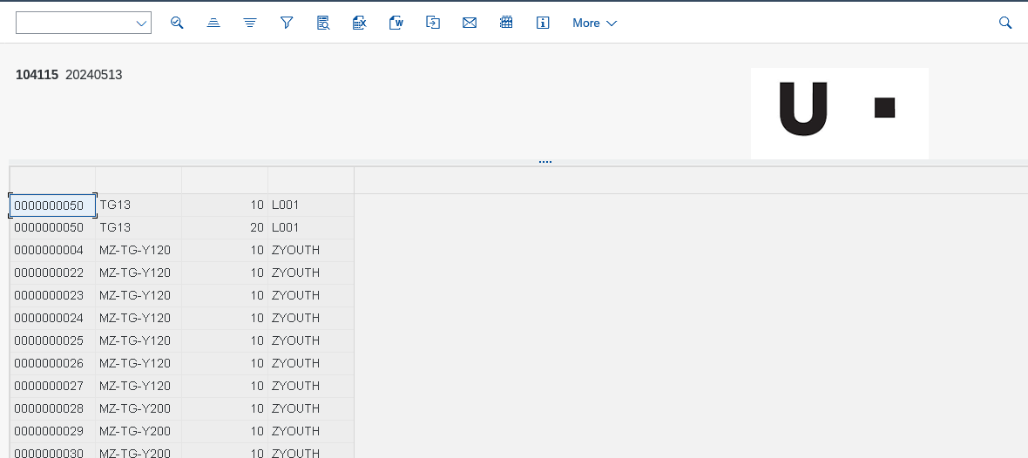

=> FOR ALL ENTRIES

REPORT Z392_FORALL.  
  
include Z392_FORALL_TOP.  
  
TABLES mara.  
  
select-OPTIONS s_matnr for mara-matnr.  
  
START-OF-SELECTION.  
select matnr  
       ernam  
       mtart  
       matkl  
  into table it_tab1  
  from mara  
  where matnr in s_matnr.  
  
if not it_tab1[] is INITIAL . " initial  
  select matnr  
         werks  
        pstat  
    into table it_tab2  
    from marc  
  
FOR ALL ENTRIES IN it_tab1 "2  
    where matnr eq it_tab1-matnr.  
  
delete ADJACENT DUPLICATES FROM it_tab1 COMPARING matnr. "3  
    sort it_tab2 by matnr.  
  
    loop at it_tab1 into wa_tab1.  
  
READ TABLE it_tab2 into wa_tab2 with key matnr = wa_tab1-matnr BINARY SEARCH.  
  
      if sy-subrc = 0.  
  
move : wa_tab1-matnr to wa_final-matnr,  
       wa_tab1-ernam to wa_final-ernam,  
       wa_tab1-mtart to wa_final-mtart,  
       wa_tab1-matkl to wa_final-matkl,  
  
       wa_tab2-werks to wa_final-werks,  
       wa_tab2-pstat to wa_final-pstat.  
  
append wa_final to it_final.  
  
else.  
  CONTINUE.  
  ENDIF.  
  ENDLOOP.  
  
loop at it_final into wa_final.  
  write :/ wa_final-matnr,  
           wa_final-ernam,  
           wa_final-mtart,  
           wa_final-matkl,  
           wa_final-werks,  
           wa_final-pstat.  
  
  
  
endloop.  
  
else.  
  
  write:/ 'records are not found'.  
  
endif.

=> SUBROUTINES

REPORT Z392_SUBROUTINES.  
  
*data a type i value 10.  
*perform sub using a.  
*write a.  
**&---------------------------------------------------------------------*  
**& Form sub  
**&---------------------------------------------------------------------*  
**& text  
**&---------------------------------------------------------------------*  
**&      --> A  
**&---------------------------------------------------------------------*  
*FORM sub USING p_a.  
*  p_a = 50.  
*  
*  
*ENDFORM.  
  
  
*data a type i value 10.  
*perform sub changing a.  
*write a.  
**&---------------------------------------------------------------------*  
**& Form sub  
**&---------------------------------------------------------------------*  
**& text  
**&---------------------------------------------------------------------*  
**&      <-- A  
**&---------------------------------------------------------------------*  
*FORM sub  CHANGING p_a.  
*  p_a = 20.  
*  
*ENDFORM.  
  
*data c type i value 10.  
*perform sub using c.  
*  
*write c.  
**&---------------------------------------------------------------------*  
**& Form sub  
**&---------------------------------------------------------------------*  
**& text  
**&---------------------------------------------------------------------*  
**&      --> C  
**&---------------------------------------------------------------------*  
*FORM sub  USING    p_c.  
*  p_c = 20.  
*  
*ENDFORM.  
  
*data a type i value 10.  
*perform sub changing a.  
*write a.  
**&---------------------------------------------------------------------*  
**& Form sub  
**&---------------------------------------------------------------------*  
**& text  
**&---------------------------------------------------------------------*  
**&      <-- A  
**&---------------------------------------------------------------------*  
*FORM sub  CHANGING p_a.  
*  p_a = 50.  
*  
*ENDFORM.